Downtown Revitalization Public Infrastructure District
Proposal to Serve as Municipal Advisor

Request for Proposals – Municipal Advisor Services

November 2026

Disclaimer
This proposal was prepared exclusively for the benefit of and internal use by the recipient for the purpose of considering the transaction or transactions contemplated herein. Tierra Financial Advisors, LLC (“Tierra Financial Advisors”) acknowledges that this proposal may be subject to public disclosure under the Utah Government Records Access and Management Act and does not claim any portion of it as protected.
By acceptance of these materials, and notwithstanding any other express or implied agreement, arrangement, or understanding to the contrary, Tierra Financial Advisors, its affiliates and the recipient agree that the recipient (and its employees, representatives, and other agents) may disclose to any and all persons, without limitation of any kind from the commencement of discussions, the tax treatment, structure or strategy of the transaction and any fact that may be relevant to understanding such treatment, structure or strategy, and all materials of any kind (including opinions or other tax analyses) that are provided to the recipient relating to such tax treatment, structure, or strategy.
The information and any analyses contained in this presentation are taken from, or based upon, information obtained from the recipient or from publicly available sources, the completeness and accuracy of which has not been independently verified and cannot be assured by Tierra Financial Advisors. The information and any analyses in these materials reflect prevailing conditions and Tierra Financial Advisors’ views as of this date, all of which are subject to change.
To the extent projections and financial analyses are set forth herein, they may be based on estimated financial performance prepared by or in consultation with the recipient and are intended only to suggest reasonable ranges of results. The printed presentation is incomplete without reference to the oral presentation or other written materials that supplement it.
IRS Circular 230 Disclosure: Tierra Financial Advisors and its affiliates do not provide tax advice, and nothing contained herein should be construed as tax advice. Any discussion of U.S. tax matters contained herein (including any attachments) (i) was not intended or written to be used, and cannot be used, by you for the purpose of avoiding tax penalties; and (ii) was written in connection with the promotion or marketing of the matters addressed herein. Accordingly, you should seek advice based upon your particular circumstances from an independent tax advisor.

Disclosures
Tierra Financial Advisors is registered with the Securities and Exchange Commission and the MSRB. The website for the MSRB can be located at: http://www.MSRB.org. On the homepage of the MSRB website there is a link to an investor brochure that describes protections that may be provided by the MSRB Rules and how to file a complaint with an appropriate regulatory authority.
Tierra Financial Advisors serves a wide variety of other clients that may from time to time have interests that could have a direct or indirect impact on the interests of the Client such as seeking to access the new issue market with advantageous timing and with limited competition at the time of the offering. None of these other engagements or relationships would impair Tierra Financial Advisors’ ability to fulfill its regulatory duties to the Client.
Tierra Financial Advisors, LLC is a wholly owned subsidiary of D.R. Horton, Inc. D.R. Horton, Inc. is a publicly traded corporation whose stock is listed on the New York Stock Exchange. D.R. Horton, Inc. also owns a controlling interest in Forestar Group Inc., a residential lot developer. To Tierra’s knowledge, neither D.R. Horton, Inc. nor Forestar Group Inc. is a developer, landowner, or other participant in the Downtown Revitalization Public Infrastructure District or the Project.
From time to time, D.R. Horton, Inc., may engage broker-dealers, commercial banks, and/or other financial institutions while conducting regular business operations. D.R. Horton, Inc. is a national homebuilder that is primarily engaged in the acquisition and development of land and the construction and sale of residential homes. D.R. Horton, Inc. is not registered as a municipal advisor, and therefore does not engage in municipal advisory services.
MSRB Rule G-42 requires that municipal advisors provide to their client’s certain disclosures of legal or disciplinary events material to its client's evaluation of the municipal advisor or the integrity of the municipal advisor's management or advisory personnel.
There are no legal or disciplinary events that Tierra Financial Advisors deems material to the Client's evaluation of Tierra Financial Advisors, or the integrity of Tierra Financial Advisors management or advisory personnel assigned to the Client.
The SEC requires Tierra Financial Advisors as a registered municipal advisor and its individual employees who are registered as municipal advisors to file certain items of information on the SEC's Form MA or MA-I. Tierra Financial Advisors most recent Form MA and each most recent Form MA-I filed with the SEC are available on the SEC's EDGAR system.
Tierra Financial Advisors has not made any material legal or disciplinary event disclosures on Form MA or any Form MA-I filed with the SEC.

Cover Letter
[November 10, 2026]
Downtown Revitalization Public Infrastructure District
c/o Gilmore & Bell, P.C., General Counsel to the District
Attn: Randall Larsen, Aaron Wade and Adam Daly
Submitted electronically in PDF format
Dear Mr. Larsen, Mr. Wade and Mr. Daly:
Tierra Financial Advisors, LLC ("Tierra") is pleased to submit this proposal to serve as Municipal Advisor to the Downtown Revitalization Public Infrastructure District (the "District"). Tierra confirms that serving the District presents no conflicts of interest.
Understanding the District. The District's June 2025 financing – $869.4 million across three liens – committed the City's 0.5% Revitalization Sales Tax to the Delta Center and SEG redevelopment. At its September 24, 2026 meeting, the Board discussed about $680 million of Salt Palace construction proceeds in 2027, supported by the County's "fourth quarter" and the City's "5th 5th" transportation sales tax shares, which 2025 legislation allows to be redirected to the District; the Board opened accounts for the 5th-5th revenues in December 2025. With Revitalization Sales Tax collections running ahead of every 2025 projection and the 2025C Bonds on track to be retired in 2027, the District approaches this financing from strength.
Ready on Day One. Tierra has already built a proprietary cash flow model for the District that sets the 2025 Bonds and a Series 2027 issue side by side through 2054. Using first lien and second lien current interest bonds sized at 1.24x – enough to hold 1.00x in a downside case – with three years of capitalized interest, plus subordinate capital appreciation bonds and a small tranche of cash flow bonds, the identified revenues support a $680 million project fund in the base case. The model also shows where that plan is vulnerable: it depends on sales tax growth, and slower growth would put pressure on the subordinate bonds and senior coverage. Structure, coverage and growth assumptions – not just interest rates – will decide what the District can prudently borrow, and Tierra is ready to test those choices with the Board, counsel and the County from the first week (Section D and Appendix D).
Development Finance Specialists. Since November 2023, Tierra has served as municipal advisor or structuring advisor on 94 bond issues totaling $1.43 billion – every one for a development project – and over the last five years on 122 development district transactions totaling $1.7 billion. These include rated, insured, nonrated and directly placed transactions secured by sales tax, tax increment and other revenues pledged by a separate public entity – the same kind of multi-party credit the Series 2027 Bonds will be. In Utah we advise public infrastructure districts in Salem City and Heber City and are working on other development district projects throughout the state.
Creative Solutions Driven by Technical Capabilities. Tierra's advisors work hard to solve their clients' most challenging financing situations. We build tailormade, dynamic cash flow and financing models to each client's individual needs. Bespoke models support independent, client-focused advice by aligning closely with each client's unique circumstances and minimizing outside influence. This is important for the District: Tierra performs its own analysis rather than simply endorsing recommendations from third parties, which keeps every aspect of our advisory work independent. Our recommendations are grounded in data-driven modeling, comprehensive market research and a clear understanding of the District's financial objectives.
Independent, Fiduciary Advice. Tierra provides only municipal advisory services. We have no broker-dealer affiliation, trading desk or investor clients, and we do not alternate between advisory and underwriting roles. Because we build our own cash flow and sizing models rather than relying on the underwriter's, we can negotiate structure, pricing and fees from a position of knowledge – and hold underwriters accountable for their pricing on the District's behalf.
Lower Costs Through Competition and Oversight. Development finance is known for high fees and underwriter-driven terms. Tierra runs competitive underwriter selections, prices every transaction against its own comparables and monitors orders in real time. In Texas development finance, Tierra capped the underwriter's discount at $20 per bond, versus the customary $30, and our forward-funding transactions average soft costs roughly 300 basis points below competitor transactions. We will bring the same discipline to a financing of the District's size, where small improvements in spread and cost translate into millions of dollars.
Utah Experience and Local Presence. Tierra is well acquainted with Utah tax increment through our coverage of the Utah Inland Port Authority, which shortlisted Tierra for municipal advisor in 2025, where we finished second in the selection process. We have worked with many of the consultants on the District's 2025 financing, including Gilmore & Bell, Pinnacle Consulting Group and D.A. Davidson. Tierra maintains office space in Utah at 4100 N. Horton Way, Suite 300, Lehi. Tierra's parent, D.R. Horton, has been in Utah for 26 years and has 196 employees in the state.
An Experienced, Hands-On Team. I will serve as lead advisor, supported by Chris Prugar, Managing Director, and Amanda Salome, Director. Our team brings more than five decades of combined municipal finance experience, including senior-managed sales tax and tax increment financings at prior firms – among them the Utah Transit Authority and the Louisville Arena Authority restructuring, a multi-party credit combining tax increment, city and arena revenues. The full team works on every transaction, so the District will always have continuous coverage.
We would welcome the opportunity to help the District deliver the Salt Palace and the completion of the downtown entertainment district. As Managing Director and Principal of Tierra, I am authorized to contractually bind the firm. Thank you for your consideration.

Sincerely,
  Evan D. Kist, CFA, Managing Director and Principal  Tierra Financial Advisors, LLC | Amanda Salome, Director  Tierra Financial Advisors, LLC

Table of Contents
Cover Letter iii
Response to Section IV – Proposal Submission Requirements
A. Confirmation of Minimum Qualifications 1
B. Description of the Advisor 2
C. Business Philosophy and Utah Marketplace Strengths 2
D. Project Understanding and Suggested Financing Plan 3
E. Team Serving the District 7
F. Utah Sales Tax and Tax Increment Transactions 8
G. Utah Tax Increment Transactions 8
H. Approach to the Scope of Work 9
I. References 9
J. Fee Schedule 10
Appendices
Appendix A – Resumes 11
Appendix B – Bond Issues Advised Since September 2021 13
Appendix C – Credit Data and Charts 16
Appendix D – Series 2027 Preliminary Cash Flows 20

Proposal – Municipal Advisor Services

A. Confirmation of Minimum Qualifications
Tierra confirms that it can provide every service described in Section III of the RFP. Our status against each minimum qualification is set out below.
Minimum Qualification | Tierra Response
Utah sales tax and tax increment bonds > $50 million (past 5 years) | No – exception requested.* Tierra structures and prices every financing it advises; its Utah sales tax and tax increment transactions to date are below $50 million.
Utah development bonds > $50 million (past 5 years) | No – exception requested.† Tierra has advised three Utah development districts with total bond programs exceeding $50 million; however, their public market transactions to date are less than $50 million.
Registered with the MSRB and SEC as a municipal advisor | Yes. SEC File No. 867-02487 / MSRB ID K1264.
No major regulatory censure or SEC/MSRB action in the last ten years | Confirmed. Tierra has made no legal or disciplinary disclosures on Form MA or any Form MA-I. An SEC examination covering an 18-month lookback identified no material findings as of April 1, 2026.
Insurance requirement (Section VIII.H) | Tierra meets all of the insurance requirements. Please see [___] for that information.
Registration with the Utah Division of Corporations (Section VIII.D) | Yes. Tierra is registered as a foreign limited liability company with the Utah Division of Corporations and Commercial Code (Entity No. 14757367-0161).
*Exception to the first minimum qualification. At a prior firm, outside the five-year window, Mr. Kist was on a team that served as senior manager to the Utah Transit Authority on a $50 million subordinate sales tax revenue bond financing. Beyond UTA, Tierra's finance professionals, while working at broker-dealer firms, served as senior managing underwriters on more than $2.5 billion of sales tax and tax increment bond financings.
Tierra is very familiar with Utah tax increment through our coverage of the Utah Inland Port Authority, which finances its project areas with tax differential (tax increment) revenues; UIPA shortlisted Tierra for municipal advisor in 2025, and Tierra finished second in the selection process. Additionally, Tierra serves as municipal advisor to many Colorado metropolitan districts (the Utah PID legislation is largely modeled on Colorado metro districts), where urban renewal authorities use tax increment as their primary funding tool and pledge a portion of it to the overlapping development district's bonds.
Tierra's Texas experience will also serve the District well: we work on many development district financings that rely on Chapter 380/381 agreements and Tax Increment Reinvestment Zones (TIRZ) with cities and counties. Most recently (November 2026), Tierra served as municipal advisor on a $177 million development bond financing for a Texas issuer supported in part by a municipality's TIRZ revenues – a pledge requiring the municipality's consent and an interlocal agreement. Finally, the threshold measures the size of a transaction, not the depth of the advisor's role: on every financing we advise on, Tierra builds the model, structures the bonds and leads the pricing, rather than only certifying to someone else’s work.
†Exception to the second minimum qualification. Tierra specializes in municipal advisory services for special district finance, and over the last five years Tierra has advised on 122 development district bond transactions for a total par amount of $1.7 billion. We believe we are qualified to serve the District and advise the Board effectively.

B. Description of the Advisor
Tierra Financial Advisors is an independent, SEC- and MSRB-registered municipal advisory firm that works exclusively in development finance. We help districts and their municipal partners create districts, understand their financial capacity and lead their bond financings.
Ownership. Tierra Financial Advisors, LLC was established in October 2019 and is a wholly owned subsidiary of D.R. Horton, Inc. (NYSE: DHI). Tierra operates independently and only provides municipal advisory services. Tierra is dedicated to serving land use authorities, development districts and municipal partners.
Volume of business. Since inception, Tierra has served as municipal advisor on [___] development district transactions for a total par amount of [$___ billion]. We serve as municipal advisor to 62 development districts in Utah, Colorado, Texas and Arizona. Please see Appendix B for a list of our transactions over the last five years.
Utah presence. Tierra maintains office space in Utah at 4100 N. Horton Way, Suite 300, Lehi, Utah 84048. Tierra's parent, D.R. Horton, Inc., has been in business in Utah for 26 years and currently has 196 employees in the state.

C. Business Philosophy and Utah Marketplace Strengths
Tierra views its role as municipal advisor to the District as an ongoing responsibility that requires active engagement. As the District's municipal advisor, our primary objective is to be viewed as an extension of your staff. We look forward to serving the District by drawing on our in-depth knowledge of municipal markets and broad client coverage. Over their careers, Tierra's advisors have worked with nearly every type of municipal client, from cities, counties and transportation agencies to utilities, hospitals and tribal governments. Tierra has the leadership qualities, experience and capabilities that distinguish us from other municipal advisors. Resumes of our team are in Appendix A.
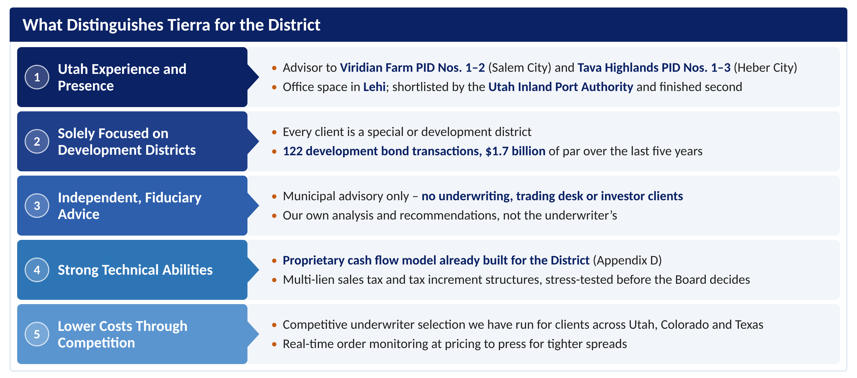
Figure 1: What distinguishes Tierra for the District
Municipal Experience & Relevant Attributes of the District’s Team
• Specialize in serving as municipal advisor to special districts, land use authorities and municipal partners (Utah PID experience)  • Extensive knowledge of general municipal finance  • Collaborative advisor with a service-oriented approach  • Experience with complex, multiphase projects  • Proven track record of providing clients with innovative ideas and solutions  • Superior technical abilities in cash flow modeling and bond structuring  • Independent, fiduciary advice – no underwriting, trading or investor clients | • Methodical in reviewing legal and relevant deal-related documentation  • Lead solicitation and selection process for underwriter(s)  • Extensive experience in long-term strategic financial planning  • Thorough understanding of Utah public finance laws  • Passionate problem-solvers and creative thinkers  • Knowledge and experience with a wide variety of debt structures, products, credits and funding mechanisms, including all those contemplated by the District  • Leadership in the marketing and pricing of municipal securities

D. Project Understanding and Suggested Financing Plan
While not officially involved in the Project, Tierra knows the District's credit in detail. In preparing this proposal we reviewed: the June 2025 Official Statement, including the senior and subordinate indentures, flow of funds, Participation Agreement, debt service schedules and pledged revenue projections; the District's EMMA continuing disclosures and monthly Revitalization Sales Tax reports; all the relevant Utah State Tax Commission data; the District's budgets and financial statements; all the Board agendas, minutes and transcripts from April 2025 through September 2026; S.B. 26 (2025), S.B. 39 (2026) and the 4th-quarter and 5th-5th transportation tax statutes (Utah Code 59-12-2219 and 59-12-2220); Salt Lake County budget documents for the Salt Palace; the 2025 bondholder base; and public reporting on the convention center reinvestment zone. From this work we understand the 2025 structure, its revenues and their collection history (Appendix C), viable alternative structures and their rating implications, and the District's plans for 2027 – for which Tierra has already built a bespoke cash flow model (Appendix D). Because the Series 2027 Bonds must fit beside the Series 2025 Bonds, we begin with a brief recap of the 2025 financing, its structure and its flow of funds.
The District and its 2025 Financing
Topic | Key Facts
District | Created by Salt Lake City on April 8, 2025 as a convention center public infrastructure district. Five-member Board appointed by the City Council (three SEG, one City, one County representative). About 10 acres today, with an annexation area of about 46 acres that includes the north half of the Convention Center block.
2025 Bonds | $649,895,000 Series 2025A First Lien (A1 underlying), $194,460,000 Series 2025B Second Lien (A3 underlying), both insured by Assured Guaranty, and $25,000,000 Series 2025C Subordinate cash flow bonds (unrated). Final maturities 2055 (A/B) and 2035 (C).
Pledged revenue | City's 0.5% Revitalization Sales Tax (Utah Code 59-12-402.5), January 2025 through December 2054, net of a 1% City administrative fee and capped District administrative expenses. Imposed at the statutory maximum rate.
Lien status and coverage | First and second liens closed to new money (refunding parity only); $900 million proceeds cap fully used. 2025 OS senior coverage begins at 111% (base case); the reduced-growth case falls to 100% in 2036.
Budget and performance | Revitalization Sales Tax of $45.8 million in 2025 (partial year), $55.9 million projected for 2026 and $57.0 million budgeted for 2027. On 2026 projections, senior debt service of $51.6 million is covered about 1.08x (Tierra calculation). The 2025C Bonds are being redeemed early from surplus revenue (Tierra interpretation of the District budget): $5.5 million in 2026, with the remaining $19.5 million budgeted for 2027. Capital outlay is budgeted at $350 million for 2027; the construction fund held $622 million at September 30, 2026.
Collections vs. 2025 projections | The District's EMMA monthly reports, which tie to the Utah State Tax Commission's distributions, show $56.5 million for calendar 2025 sales – 0.9% above the Official Statement base case ($56.0 million) and 1.9% above the reduced-growth case. January–August 2026 is up 4.5% on 2025, more than double the 2.0% the base case assumed, and trailing-12-month collections of $58.1 million already exceed the base case for all of 2026 ($57.1 million). On that trend, senior coverage for the bond year ending June 1, 2027 is about 1.15x versus 1.12x projected (Tierra calculation). The FYE 2025 annual report and audit were posted September 9, 2026, ahead of the September 30 deadline.
The Salt Palace, the Reinvestment Zone and the County
Topic | Key Facts
Legislation | S.B. 26 (2025) authorized a convention center public infrastructure district and a convention center reinvestment zone. A district within or adjacent to the zone may issue bonds for convention revitalization projects; under the District's interlocal agreement with the County, the Salt Lake County Mayor approves expenditures of zone revenue other than District bonds (Utah Code 17D-4-202.1, 17D-4-203). S.B. 39 (2026) recodified the investment zone statutes.
The zone | Approved by the State's Housing and Transit Reinvestment Zone Committee on April 4, 2025: about 50 acres, including the Salt Palace, Abravanel Hall, UMOCA and Block 67. Reported capture of local sales tax increment, part of the State sales tax increment and 100% of new property tax for about 30 years. (Capture percentages and base-year value to be confirmed against the statute and the approved zone proposal.)
Project cost | About $1.8 billion of zone projects: roughly $1.28 billion for the Salt Palace (including a second ballroom), about $229 million for Abravanel Hall, UMOCA and the east plaza, and Block 67 parking.
Salt Palace schedule | County in Phase II design (April 2026). Jacobsen Construction / AECOM Hunt (construction), MHTN and Populous (architects), Legends Global (operator). Western portion sold to SEG ($55.4 million), with transfer expected in February 2027. Closes fall 2027 for about three years; completion targeted for 2031.
County funding | The County's 2026 budget includes a Salt Palace Renovation Project fund ($48.1 million beginning balance), $4.1 million of Salt Palace debt service transfers, and a $150 million Visitor and Promotion Fund sales tax revenue bond in its financing plans.
Series 2027 plan | The plan dates to May 2025, when the County's trustee said the County intended to "monetize the full amount for the Salt Palace project" and to assign transportation taxes to the District. At the September 24, 2026 meeting, the Board discussed a Series 2027 ("Series D") issue by the District for the Salt Palace renovation: interlocal agreements would bring "the city's fifth" and "the county's fourth quarter" revenues into the District to bolster the Revitalization Sales Tax, with targeted construction proceeds of about $680 million.
New revenue sources | County share of the 4th quarter (Utah Code 59-12-2219): 0.25% countywide transportation tax; the County's 0.05% share was $19.4 million in 2024, $19.75 million in 2025 and up about 3.5% on an annualized basis in 2026. A first-class county may transfer this revenue to a convention center PID. City share of the 5th 5th (59-12-2220): 0.20% countywide tax effective July 2025; a “capital city” must transfer at least 50% (up to 100%) of its share – about $4.8 million in its first 12 months of distributions – to the PID for the bondable term. In December 2025, the Board opened accounts to receive the 5th-5th of revenues. Salt Lake City's combined 8.45% rate is otherwise at its statutory maximum. (Shares to be pledged need to be confirmed.)
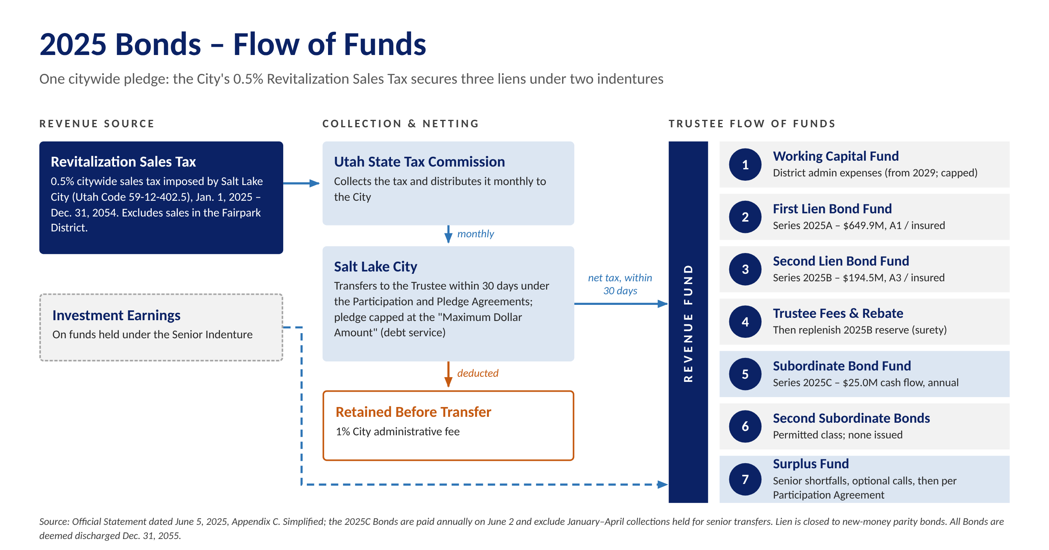
Figure 2: 2025 Bonds flow of funds (simplified from the Official Statement by Tierra)
Charts of collections, coverage and Series 2027 sizing are in Appendix C.
What This Means for the 2027 Bonds
- Fitting beside the 2025 liens. The first and second liens are closed to new money, and the 2025 indenture permits Second Subordinate Bonds only when no Subordinate Bonds are outstanding. The District's 2027 budget shows the remaining $19.5 million of 2025C Bonds paid down with cash; they are also callable at par from January 15, 2027, so refunding them as part of the Series 2027 issue is another possibility. The Series 2027 Bonds could take a junior lien on the Revitalization Sales Tax together with a first lien on the new City and County revenues, or sit under a separate indenture with the sales tax surplus as secondary support. Both must be tested with counsel against the Participation Agreement ($900 million cap and Maximum Dollar Amount) and the statutory limits on the tax.
- How revenue would flow. We would expect a new indenture for the Series 2027 Bonds that ties into the 2025 waterfall. The County's 4th-quarter share and the City's 5th-5th share would go to the Series 2027 trustee with a first lien. The Revitalization Sales Tax would still pay the 2025A and 2025B Bonds first; what remains would go to the Series 2027 Bonds through the 2025 indenture's subordinate position only if the 2025C Bonds are refunded/paid down – not through the Surplus Fund, which is released under the Participation Agreement. The 2027 indenture would then pay 2027A, 2027B and 2027C debt service and fund a rate stabilization fund before any release (Figure C-5 in Appendix __?).
- Interlocal agreements are the credit documents. Each must be irrevocable for the life of the bonds, define the revenue and its priority against the City's and County's other obligations, include non-impairment and additional bonds covenants, and route revenue directly to the trustee. The County must commit its 4th-quarter share for the full term, and the City's 5th-5th transfer must run for the bondable term; both depend on countywide taxes the County could change, which investors will scrutinize.
- Variability in rates. Rising rates were a concern the Board raised at its September 24, 2026 meeting. For perspective, each 50 basis point rise in rates reduces proceeds by about $45 million under a rising debt service structure. We would be happy to share a more detailed funding and scenario analysis with the Board upon request.
- The County is a partner. The County owns and will rebuild the Salt Palace and is already budgeting Salt Palace debt service and its own $150 million Visitor and Promotion Fund bonds.
Alternative Structures and Rating Implications
Structure | When It Fits | Rating / Market Implication
Combined pledge: junior lien on the Revitalization Sales Tax plus first lien on the County 4th-quarter and City 5th-5th shares | After the 2025C Bonds are retired – paid down with cash, as the 2027 budget shows, or refunded into the Series 2027 issue | Broadest security; rating rests mainly on the new revenues; insurance possible as in 2025
Separate indenture on the County and City transportation-tax shares, with sales tax surplus as secondary support | If the 2025 documents limit junior liens, or a cleaner credit is preferred | Rated on the new revenues alone; simpler for investors to analyze
Phased issuance or draw-down placement | Draws extend over several years (Salt Palace closes fall 2027; completion targeted for 2031) | Reduces negative arbitrage and capitalized interest; later series priced on actual collections
Rating agencies will focus on the breadth of the countywide County and City shares, the irrevocability of each pledge, coverage at maximum annual debt service and the additional bonds test. The task in 2027 is to earn strong ratings on the new revenues while keeping the 2025 liens and their coverage intact.
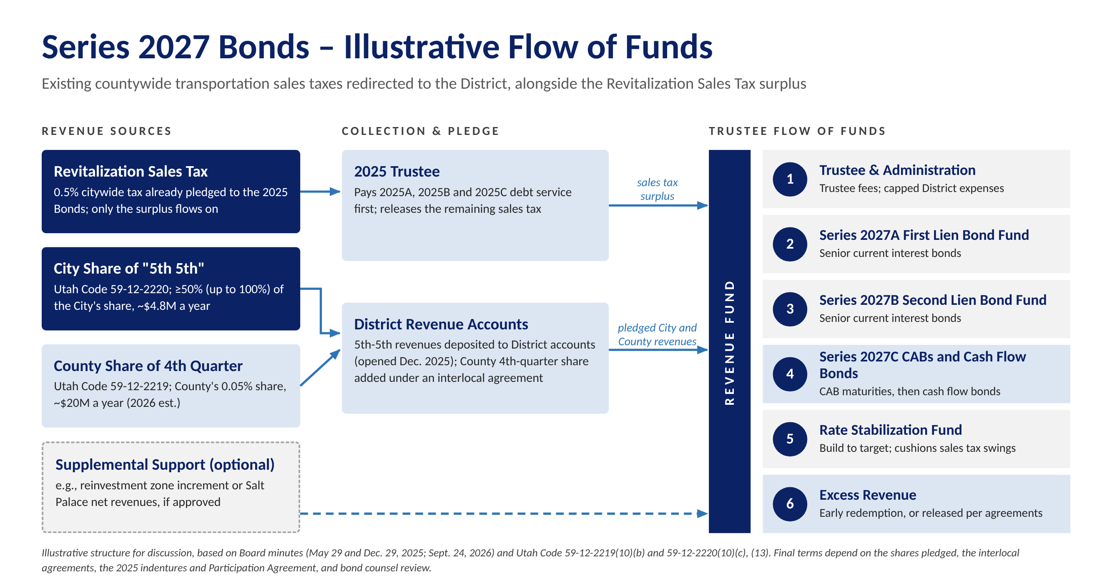
Figure 3: Series 2027 Bonds – illustrative flow of funds
Tierra's Series 2027 Model
Tierra has built a proprietary cash flow model for the District that sets the 2025 bonds alongside a proposed Series 2027 financing. Using a combination of 2027A first lien and 2027B second lien current interest bonds plus subordinate 2027C bonds, the identified revenues (about $32 million in 2028) support net proceeds of $680 million. This outcome is for our base case scenario. Please see our illustrative sources and uses table below. Additionally, we have also tested a downside case and a reduced growth case. In our downside case senior coverage holds at 1.00x and every bond is still paid. However, under our reduced growth case senior coverage falls to about 0.66x. More detail regarding these different scenarios can be found in Appendix __?
Tierra is ready to hit the ground running. Our proprietary model is built and ready to test pledges, structures, rates and timing considerations for the District,.
Illustrative Sources and Uses (base case) | Amount
Sources: 2027A first lien / 2027B second lien bonds | $422.2M / $119.5M
Sources: 2027C-1 subordinate CABs (initial value) / 2027C-2 cash flow bonds | $107.1M / $45.9M
Uses: Project fund / underwriter's discount / costs of issuance / capitalized interest | $680.0M / $5.1M / $3.8M / $5.9M
Senior debt service from revenue, 2028 / maximum (level from 2038) | $25.8M / $44.8M
CAB maturity value, total / maximum annual | $427.1M / $51.2M
Tierra estimate; 1.24x senior coverage; capitalized interest through June 1, 2030; 5.25% first lien and 5.50% second lien bonds, 6.50% CABs and 7.50% cash flow bonds, final maturity 2054, 100% of the County and City shares pledged, costs at Series 2025 rates; no reserve fund or 2025C refunding.
Structuring Options Tested
We tested five structures in the model, each delivering the $680 million project fund. The first – senior bonds plus subordinate cash flow bonds, like the 2025 financing – needs about $241 million of cash flow bonds, more than the market is likely to absorb and $155 million of which would go unpaid in the downside case. Splitting the subordinate bonds between capital appreciation bonds (CABs) and cash flow bonds, adding three years of capitalized interest, sizing the senior bonds to hold 1.00x in the downside case and starting the CAB maturities in 2041 – after the senior debt service levels off – produces a structure in which every bond is paid in the downside case (Appendix C-3 and Appendix D).
Option (each adds to the one above) | Senior / CABs / Cash Flow Bonds | Senior Coverage: Base / Downside | Downside Case Result
All cash flow bonds; 1.25x senior; no CAPI | $448M / $0M / $241M | 1.25x / 1.01x | $155M of cash flow bonds unpaid at 2054
Split 2027C 70% CABs / 30% cash flow bonds | $448M / $169M / $72M | 1.25x / 1.01x | $25M of CAB maturities unpaid
Add 3 years of CAPI; 1.15x senior; ramp to 2038 | $583M / $78M / $34M | 1.15x / 0.93x | $21M of CAB maturities unpaid
Raise senior coverage to 1.24x (1.00x in the downside) | $542M / $107M / $46M | 1.24x / 1.00x | $26M of CAB maturities unpaid
Start CAB maturities in 2041 (recommended) | $542M / $107M / $46M | 1.24x / 1.00x | All paid; cash flow bonds repaid by 2053
Suggested Financing Plan and Timeline
[insert what our suggested finance plan is. I think it is the CAPI 1.15x structure for now. Claude add in a summary paragraph]
Timing | Key Activities
Nov 2026 – Feb 2027 | Review the 2025 indentures, Participation Agreement and S.B. 26 for lien capacity; confirm the County 4th-quarter and City 5th-5th shares to be pledged and their collection history; build an integrated model of the 2025 and Series 2027 credits; identify legal and tax questions for counsel.
Feb – May 2027 | Recommend security, lien structure, sizing, timing and method of sale; present options to the Board; negotiate interlocal pledge terms with the City, County and State.
Apr – Jul 2027 | Run underwriter selection; develop rating and insurance strategy; draft documents.
Second half 2027 | Rating presentations, investor outreach, pricing and closing of the first series ahead of the Salt Palace closure in fall 2027; evaluate later series against the County's draw schedule.

E. Team Serving the District
Evan Kist, CFA, will be the lead advisor. All Tierra advisors report directly to Mr. Kist, and the full team works on every transaction so knowledge is shared and coverage is continuous. Detailed resumes are in Appendix A.
Team Member | Responsibilities | Experience and Education
Evan Kist, CFA  Managing Director & Principal  Lead Advisor  Series 50 & 54 | Overall strategy and credit structuring; cash flow and sizing models; negotiations with the City, County, State and underwriters; leads pricing; presents to the Board; supervises all work product and compliance. | Started Tierra in September 2019. More than 20 years in municipal finance, including 10 years at Merrill Lynch. BA Economics, University of New Mexico (Phi Beta Kappa); CFA charterholder.
Amanda Salome  Director  Day-to-Day Advisor  Series 50 | Document review, due diligence, POS/OS coordination, financing schedules, procurement of underwriters and other professionals, continuing disclosure support. | Joined Tierra in 2025. More than 15 years in investment and commercial banking, including J.P. Morgan and Merrill Lynch. BA Economics and Geographical Studies, University of Chicago.
Chris Prugar  Managing Director  Day-to-Day Advisor  Series 50 | Rating agency and investor materials, transaction execution. | Joined Tierra in 2022 2022. More than 16 years in public finance, including BofA Securities. BS Business Administration, Washington and Lee University (cum laude).

F. Utah Sales Tax and Tax Increment Transactions
[better lead in] Tierra is working on many tax increment financings in Texas and elsewhere; negotiations over developments and incentives can take years to finalize. See also our response to Section A.
New Mexico gross receipts tax and transportation credits. Before founding Tierra, Mr. Kist covered large New Mexico cities and counties, whose gross receipts tax bonds are essentially sales tax revenue bonds, including Bernalillo County's $12.08 million sales tax revenue bonds (2018). New Mexico allocates increments of its local and state gross receipts taxes to development projects much as Utah allocates shares of local option sales taxes to the District. His work also included sales tax revenue bonds for Dallas Area Rapid Transit and the Utah Transit Authority.
Merrill Lynch experience: [TBD] Talk about the sales tax revenue bond experience. $2.5 billion. Convention center experience and Chris’s experience. Louisville Arena Authority (Mr. Prugar). Mr. Prugar was part of the financing team that restructured the Louisville Arena Authority's 2008 bonds for the KFC Yum! Center, which had been downgraded below investment grade. The new structure combined tax increment, a guaranteed City payment, and arena and lease revenues; Mr. Prugar presented the credit to the rating agencies, and the bonds achieved A- (S&P) and Baa3 (Moody's) ratings and became eligible for bond insurance – a multi-party, multi-revenue credit much like the Series 2027 Bonds.

Colorado urban renewal authorities. Tierra serves as municipal advisor to Colorado metropolitan districts that overlap urban renewal areas. Urban renewal authority pledges a portion of its tax increment to the district's bonds under a cooperation agreement (e.g., Liberty Ranch's 2021 refunding, secured in part by Mead Urban Renewal Area increment). Talk about St. Vrain Mill Levy Equalization and and Firestone URA revenues.
Other: Kemah, Chicago casino, Seminole tribe of florida hard rock casino and hotel

G. Utah Tax Increment Transactions
Tierra has not advised on a Utah tax increment bond issue. Outside of Utah, Tierra regularly models and negotiates tax increment participation, including Colorado urban renewal cooperation agreements and Texas Tax Increment Reinvestment Zones, and has studied the Utah precedents most relevant to the District: UIPA's 2021 Crossroads PID tax differential bonds, MIDA's 2021 financing and The Point Phase 1 PID No. 1 bonds (2025) [better explain the understanding of the Utah deals mentioned. And their TIF increments and pledges and flow of funds]. Mr. Kist has extensive tax increment financing experience in comparable markets such as Colorado, and he recently executed a $177 million development district financing for a Texas issuer secured in part by TIRZ revenues from a Texas city.

H. Approach to the Scope of Work
Creative solutions driven by technical capabilities. Tierra's advisors work hard to solve their clients' most challenging financing situations. We build tailormade, dynamic cash flow and financing models to each client's needs and perform our own analysis rather than endorsing recommendations from underwriters or other parties, keeping our advice independent. Our recommendations are grounded in data-driven modeling, comprehensive market research and a clear understanding of the District's financial objectives. Resources: a three-person team, our in-house models and market data (Bloomberg, MSRB EMMA, a land-secured comparables database).
Section III Service | Tierra's Approach
A. Current debt and refunding | Monitor the 2025 Bonds against call dates (2025A 2036–2039 maturities June 1, 2030; later maturities and 2025B June 1, 2035; 2025C from January 15, 2027). Measure savings against each call's option value, not just a 3% present value test. Refundings can also restructure liens or covenants; tax-exempt refundings must be current (within 90 days of a call).
B. Future debt issues | Plan of finance for the 2027 bonds (Section D): security, liens, sizing, timing and method of sale, stress-tested for recession and higher rates.
C. Life-cycle cost | Compare all-in cost of each alternative, including issuance costs, insurance and surety premiums, capitalized interest (if necessary), negative arbitrage and reserve funding, in present value terms.
D. Documents | Work with bond and disclosure counsel and underwriters on the POS/OS, indentures and pledge agreements; coordinate printing and distribution.
E. Underwriting bids | Run a competitive selection; require a marketing book, pre-pricing calls and real-time order access (Gameday); price against our own comparables; resist over-collateralization and inflated fees; favor buy-and-hold investors; hold underwriters to their indications. Target the 82 holders of the 2025 Bonds.
F. Legal review | Review all documents for consistency with the plan of finance, the Governing Document and the 2025 indentures.
G. Compliance | Support continuing disclosure filings, coordinate rebate on the $622 million 2025 construction fund and future proceeds, and track post-issuance compliance.
H. Market developments | Regular market updates on rates, investor demand for sales tax and increment credits, federal tax policy affecting tax-exempt bonds, and SEC and MSRB developments.
I. Meetings | Attend due diligence sessions and Board meetings as requested; provide "Bonds 101" sessions for staff and Board members.
J. Credit ratings | In coordination with the financing team, develop rating and insurance strategy, prepare rating agency presentations and lead the rating process.

I. References
Client | Contact Person and Title | Contact Information
National Finance Authority | John Stoecker, Program Administrator | john@nfabonds.com
St. Vrain Lakes Metropolitan District No. 2 (CO) | Matt Castillo, Director of Business Strategies | [email needed]
North Collin County MUD No. 1 (TX) | Drew McLoughlin, Director of Finance | drew@heiinc.com
California Municipal Finance Authority | Lee McCormick, [Program Administrator – confirm title] | [CMFA email needed]
Tierra is proud to have worked with many of the consultants involved in the District's 2025 financing. We have worked on bond financings and/or have a strong working relationship with Gilmore & Bell (bond, disclosure and District counsel), Pinnacle Consulting Group (District accountant) and D.A. Davidson (co-managing underwriter). Additional references are available upon request.

J. Fee Schedule
Tierra's fees are payable only if a financing closes. [EVAN TO CONFIRM rates and caps (carried over from the Point of the Mountain proposal).]
Service | Fee
Sales tax revenue bonds (public offering or private placement) | 0.100% of principal amount; minimum $30,000; not to exceed $100,000 per series
Tax increment revenue bonds (public offering or private placement) | 0.125% of principal amount; minimum $30,000; not to exceed $125,000 per series
Refunding bonds | [Same as the applicable new-money fee]
Continuing disclosure assistance | No additional charge
Ongoing advisory services outside a financing (e.g., refunding monitoring, Board meetings, market updates) | [No additional charge / hourly at $150 per hour for Principal and Managing Director, $100 per hour for Senior Analyst]
Out-of-pocket expenses | [Reimbursed at cost / included in fee]

Appendix A – Resumes
Evan Kist, CFA, Managing Director and Principal, Tierra Financial Advisors
Primary Contact
Texas / Utah | Utah office: 4100 N. Horton Way, Suite 300, Lehi, UT 84048
Evan has over 20 years of municipal finance experience and currently manages Tierra's municipal advisory business and strategy. He is the firm's Principal and leads the firm's quantitative development, structuring and solution delivery for existing and new clients. He also directs supervisory procedures and legal, compliance and regulatory requirements for the organization.
Evan currently serves as municipal advisor to development districts in Utah, Colorado and Texas. His special district clients include Viridian Farm Public Improvement District (Salem City), Tava Highlands Public Improvement District Nos. 1 – 3 (Heber City), Liberty Ranch Metropolitan District, Parkside Metropolitan District, Heritage Ridge Metropolitan District, Northridge Estates Metropolitan District No. 3, St. Vrain Lakes Metropolitan District No. 2, and numerous Texas municipal utility districts.
Prior to joining Tierra in August 2019, Evan worked for RBC Capital Markets, where he served a large portfolio of clients as either a municipal advisor or senior managing underwriter. In both roles his clients included cities, counties, state-level agencies, regional water authorities, transportation systems, development districts, tribal governments and school districts.
Evan spent 10 years working for Merrill Lynch (now BofA Securities) in their New York and Chicago offices covering municipal issuers throughout the country, including power and energy, transportation, water, infrastructure, hospital systems, and special situation borrowers. He worked on 50+ senior managed public finance transactions totaling $8 billion, for clients such as New York City, Texas Department of Transportation, Dallas Area Rapid Transit, CPS Energy, State Revolving Funds (ND, IN), Jefferson County, AL (special advisor to the County during bankruptcy) and Parkland Hospital.
Evan graduated Phi Beta Kappa with a degree in Economics and minor in Finance from the University of New Mexico and is a Chartered Financial Analyst ("CFA") charterholder. He is an SEC registered municipal advisor holding the Series 50 and 54 licenses.

Chris Prugar, Managing Director, Tierra Financial Advisors
Day-to-Day / Backup Contact
Houston, Texas
Chris has over 16 years of public finance experience and has served in a wide variety of roles structuring, executing, and managing municipal bond transactions. Chris joined Tierra in April 2022 and serves as municipal advisor to many special districts located in Texas, and also supports Tierra's municipal advisory efforts in Colorado, Utah and Arizona.
Prior to joining Tierra, Chris worked for BofA Securities where he sourced negotiated bond transactions for special districts, water and sewer authorities, cities, counties, school districts, and special projects. His experience includes detailed cash flow modeling, client presentations, rating agency presentations, interfacing with the sales desk and transaction execution. Chris has been involved in over $20 billion of transactions, including Texas Municipal Gas Supply and Acquisition Corporation III (gas prepays), Unemployment Trust Fund financings, Texas Private Activity Bond Surface Transportation Corporation, Louisville Arena Authority, Louisiana Stadium and Exposition District (Superdome) and the City of Houston Airport System.
Chris graduated cum laude from Washington and Lee University with a Bachelor of Science in Business Administration. He is an SEC registered municipal advisor holding the Series 50 license.

Amanda Salome, Director, Tierra Financial Advisors
Day-to-Day / Backup Contact
Austin, Texas
Amanda brings over 15 years of investment and commercial banking experience to her role as Director at Tierra. She leads financial structuring, analytics, and strategic planning efforts and currently serves over 15 special financing districts across Utah, Colorado, and Texas.
Prior to joining Tierra, Amanda served as Executive Director at J.P. Morgan Chase, managing a portfolio of 40 healthcare, higher education, and nonprofit clients across the Southern region, and was a key member of J.P. Morgan's national DBC Analytics Team. Earlier in her career, Amanda spent over a decade at Merrill Lynch (now BofA Securities), where she helped lead over 70 bond transactions totaling more than $9 billion in par value across 20 states.
Amanda holds a BA in Economics and Geographical Studies from the University of Chicago. She is an SEC registered municipal advisor holding the Series 50 license.

Appendix B – Bond Issues Advised Since September 2021
The following is a complete list of the municipal bond issues on which Tierra served as municipal advisor or structuring advisor over the past five years: 122 transactions totaling $1.65 billion, every one for a development project, across Texas, Colorado and Utah.
Delivery | Issuer | State | Series | Par Amount ($) | Tierra Role | Moody's / S&P
12/08/26 | Waller Co MUD #47 | TX | U/L Tax Road Bds Ser 2026 | 2,000,000 | Municipal | NR
11/10/26 | Huffines DFW Projects | TX | Special Rev Bds Ser 2026 | 66,496,971 | Structuring | NR
09/30/26 | Beazer Pooled Project | TX | Special Rev Bds Ser 2026 | 73,140,000 | Structuring | NR
09/30/26 | Viridian Farm Public Infrastructure District #2 | UT | Ltd Tax Bds Ser 2026A | 7,180,000 | Municipal | NR
09/30/26 | Viridian Farm Public Infrastructure District #2 | UT | Sub Ltd Bds 2026B | 1,410,000 | Municipal | NR
09/29/26 | Silver Peaks Metropolitan District No. 6 | CO | Ltd Tax Bds Ser 2026A | 7,500,000 | Municipal | NR
09/29/26 | Silver Peaks Metropolitan District No. 6 | CO | Sub Ltd Bds 2026B | 1,980,000 | Municipal | NR
09/28/26 | Montgomery Co MUD #202A | TX | U/L Tax Road Bds Ser 2026 | 5,000,000 | Municipal | NR / NR / AA
09/10/26 | Fort Bend MUD No #222 | TX | U/L Tax Util Bds Ser 2026 | 20,000,000 | Municipal | NR / NR / AA
09/10/26 | Brazoria Co MUD #87 | TX | U/L Tax Road Bds Ser 2026 | 3,000,000 | Municipal | NR / NR / AA
08/27/26 | Fort Bend Co MUD #232 | TX | U/L Tax Util Bds Ser 2026 | 7,500,000 | Municipal | NR / NR / AA
08/24/26 | Ellis Co MUD #1B | TX | U/L Tax Util Bds Ser 2026 | 4,090,000 | Municipal | NR / NR / AA
08/20/26 | Fort Bend Co MUD #246 | TX | U/L Tax Util Bds Ser 2026 | 10,000,000 | Municipal | NR / NR / AA
08/20/26 | Legends Ranch MUD | TX | U/L Tax Road Bds Ser 2026 | 4,210,000 | Municipal | NR / NR / AA
08/20/26 | Legends Ranch MUD | TX | U/L Tax Util Bds Ser 2026 | 7,950,000 | Municipal | NR / NR / AA
08/19/26 | Brazoria Co MUD #81 | TX | U/L Tax Road Bds Ser 2026 | 3,000,000 | Municipal | NR / NR / AA
08/12/26 | Montgomery Co MUD #139 | TX | U/L Tax Util Bds Ser 2026 | 3,000,000 | Municipal | Baa1 / NR / AA
08/10/26 | Dallas Co MUD #4 | TX | U/L Tax Road Bds Ser 2026 | 3,265,000 | Municipal | NR / NR / AA
08/10/26 | Dallas Co MUD #4 | TX | U/L Tax Util Bds Ser 2026 | 5,870,000 | Municipal | NR / NR / AA
07/16/26 | Brazoria-Fort Bend Counties MUD #3 | TX | U/L Tax Road Bds Ser 2026 | 5,000,000 | Municipal | Baa3 / NR / AA
07/15/26 | East Hays Co MUD #1 | TX | U/L Tax Util Bds Ser 2026 | 6,000,000 | Municipal | NR / NR / AA
07/15/26 | Collin County MUD #4 | TX | U/L Tax Util Bds Ser 2026 | 11,570,000 | Municipal | A1 / Baa3 / NR / AA
07/15/26 | Collin County MUD #4 | TX | U/L Tax Road Bds Ser 2026 | 2,320,000 | Municipal | A1 / Baa3 / NR / AA
07/15/26 | Riverfield MUD #1 | TX | U/L Tax Util Bds Ser 2026 | 2,125,000 | Municipal | NR / NR / AA
07/15/26 | Fort Bend Co MUD #188 | TX | U/L Tax Road Bds Ser 2026 | 5,000,000 | Municipal | NR / NR / AA
06/30/26 | Lakeside Bayou Project | TX | Special Rev Bds Ser 2026 | 21,345,792 | Structuring | NR
04/16/26 | HistoryMaker/Empire Projects | TX | Special Rev Bds Ser 2026 | 31,630,000 | Structuring | NR
03/30/26 | Forestar Group Houston-Area Projects | TX | Special Rev Bds Ser 2026 | 153,000,000 | Structuring | NR
03/24/26 | Montgomery Co MUD #199 | TX | U/L Tax Road Bds Ser 2026 | 9,650,000 | Municipal | NR
12/23/25 | Katy Court Project - Development I | TX | Special Rev Bds Ser 2026 | 11,904,000 | Structuring | NR
12/23/25 | Katy Court Project - Development II | TX | Special Rev Bds Ser 2026 | 6,773,000 | Structuring | NR
12/23/25 | Katy Court Project - Development III | TX | Special Rev Bds Ser 2026 | 6,753,000 | Structuring | NR
12/09/25 | Ellston Park Metropolitan District | CO | Ltd Tax Bds Ser 2025A | 2,235,000 | Municipal | NR
12/09/25 | Ellston Park Metropolitan District | CO | Sub Ltd Bds 2025B | 295,000 | Municipal | NR
09/23/25 | East Montgomery Co MUD # 14 | TX | U/L Tax Util Bds Ser 2025 | 4,000,000 | Municipal | NR / NR / AA
09/23/25 | Fort Bend MUD #232 | TX | U/L Tax Util Bds Ser 2025 | 5,400,000 | Municipal | NR / NR / AA
09/18/25 | Fort Bend MUD #246 | TX | U/L Tax Util Bds Ser 2025 | 5,200,000 | Municipal | NR / NR / AA
09/10/25 | Austin Co MUD #1 | TX | U/L Tax Road Bds Ser 2025 | 5,000,000 | Municipal | NR
08/26/25 | East Hays Co MUD #1 | TX | U/L Tax Util Bds Ser 2025 | 6,080,000 | Municipal | NR / NR / AA
08/26/25 | East Hays Co MUD #1 | TX | U/L Tax Road Bds Ser 2025 | 3,440,000 | Municipal | NR / NR / AA
08/19/25 | Brazoria-Fort Bend Counties MUD #3 | TX | U/L Tax Util Bds Ser 2025 | 8,000,000 | Municipal | Baa3 / NR / AA
08/19/25 | Brazoria-Fort Bend Counties MUD #3 | TX | U/L Tax Road Bds Ser 2025 | 6,500,000 | Municipal | Baa3 / NR / AA
08/14/25 | Collin Co MUD CR 412 | TX | U/L Tax Util Bds Ser 2025 | 5,200,000 | Municipal | NR / NR / AA
08/12/25 | Montgomery Co MUD #139 | TX | U/L Tax Util Bds Ser 2025 | 3,885,000 | Municipal | Baa1 / NR / AA
08/12/25 | Montgomery Co MUD #139 | TX | U/L Tax Road Bds Ser 2025 | 2,815,000 | Municipal | Baa1 / NR / AA
08/12/25 | Fort Bend Co MUD #222 | TX | U/L Tax Util Bds Ser 2025 | 25,000,000 | Municipal | NR / NR / AA
08/11/25 | Dallas Co MUD #4 | TX | U/L Tax Util Bds Ser 2025 | 6,865,000 | Municipal | NR / NR / AA
08/11/25 | Dallas Co MUD #4 | TX | U/L Tax Road Bds Ser 2025 | 3,780,000 | Municipal | NR / NR / AA
08/06/25 | Grand Pines Project (Special Revenue Bonds) | TX | Special Rev Bds Ser 2025 | 27,273,000 | Structuring | NR
08/06/25 | Magnolia Pointe MUD # 1 | TX | U/L Tax Util Bds Ser 2025 | 2,525,000 | Municipal | Baa2 / NR / AA
08/06/25 | Magnolia Pointe MUD # 1 | TX | U/L Tax Road Bds Ser 2025 | 3,275,000 | Municipal | Baa2 / NR / AA
07/09/25 | Riverfield MUD #1 | TX | U/L Tax Road Bds Ser 2025 | 4,120,000 | Municipal | NR / NR / AA
07/09/25 | Riverfield MUD #1 | TX | U/L Tax Util Bds Ser 2025 | 5,980,000 | Municipal | NR / NR / AA
07/09/25 | Collin County MUD #4 | TX | U/L Tax Road Bds Ser 2025 | 6,270,000 | Municipal | A1 / Baa3 / NR / AA
07/09/25 | Collin County MUD #4 | TX | U/L Tax Util Bds Ser 2025 | 8,630,000 | Municipal | A1 / Baa3 / NR / AA
06/26/25 | Montgomery County MUD 165 (Mill Creek Project) | TX | Special Rev Bds Ser 2025 | 26,685,000 | Structuring | NR
05/29/25 | Mirador Project | TX | Special Rev Bds Ser 2025 | 36,550,000 | Municipal | NR
05/28/25 | Timberleaf Metropolitan District | CO | U/L Tax Ref Bds Ser 2025A | 9,895,000 | Municipal | NR / AA
05/28/25 | Timberleaf Metropolitan District | CO | Ltd Tax Bds Ser 2025B | 1,850,000 | Municipal | NR
05/15/25 | Fort Bend Co MUD # 188 | TX | U/L Tax Util Bds Ser 2025 | 15,000,000 | Municipal | NR / NR / AA
04/24/25 | Princeton Area Projects (Special Revenue Bonds) | TX | Limited Tax Bds Ser 2025 | 52,830,000 | Structuring | NR
04/15/25 | Ellis Co MUD # 1B | TX | U/L Tax Util Bds Ser 2025 | 4,700,000 | Municipal | NR
03/19/25 | Lackland Projects | TX | Special Rev Bds Ser 2025 | 85,566,271 | Municipal | NR
02/27/25 | Four Corners Business Improvement District | CO | Sub Ltd Tax Rev Bds Ser 2025B | 1,875,000 | Municipal | NR
11/26/24 | St. Vrain Lakes Metropolitan District #2 | CO | Ltd Tax Ref Bds Ser 2024A | 40,855,000 | Municipal | NR / AA / BBB
11/26/24 | St. Vrain Lakes Metropolitan District #2 | CO | Sub Ltd Tax Ref Bds Ser 2024B | 17,700,000 | Municipal | NR
11/13/24 | Easton Park Project (Districts 2 and 5) | TX | Limited Tax Bds Ser 2024 | 45,430,000 | Municipal | NR
11/06/24 | Silverado Project | TX | Special Rev Bds Ser 2024 | 47,300,000 | Structuring | NR
10/23/24 | Poetry Road MUD | TX | U/L Tax Util Bds Ser 2024 | 4,010,000 | Municipal | NR
09/27/24 | Dallas Co MUD # 4 | TX | U/L Tax Util Bds Ser 2024 | 5,730,000 | Municipal | NR / NR / AA
09/26/24 | Viridian Farm Public Infrastructure District #1 | UT | Limited Tax Bds Ser 2024A | 5,645,000 | Municipal | NR
09/26/24 | Viridian Farm Public Infrastructure District #1 | UT | Sub Limited Tax Bds Ser 2024B | 1,000,000 | Municipal | NR
09/26/24 | Collin Co MUD CR 412 | TX | U/L Tax Util Bds Ser 2024 | 4,580,000 | Municipal | NR
09/26/24 | Fort Bend Co MUD # 232 | TX | U/L Tax Road Bds Ser 2024 | 3,250,000 | Municipal | NR
09/26/24 | Montgomery Co MUD # 199 | TX | U/L Tax Road Bds Ser 2024 | 5,000,000 | Municipal | NR
09/24/24 | East Montgomery Co MUD # 14 | TX | U/L Tax Road Bds Ser 2024 | 3,575,000 | Municipal | NR / NR / AA
09/24/24 | Fort Bend Co MUD # 246 | TX | U/L Tax Road Bds Ser 2024 | 2,500,000 | Municipal | NR
09/17/24 | Magnolia Pointe MUD # 1 | TX | U/L Tax Road Bds Ser 2024 | 5,250,000 | Municipal | Baa2 / NR / AA
09/17/24 | Magnolia Pointe MUD # 1 | TX | U/L Tax Util Bds Ser 2024 | 20,000,000 | Municipal | Baa2 / NR / AA
09/11/24 | Fort Bend Co MUD # 222 | TX | U/L Tax Road Bds Ser 2024 | 12,585,000 | Municipal | NR / NR / AA
08/21/24 | Tamarron Project | TX | Special Rev Bds Ser 2025 | 168,325,000 | Structuring | NR
08/20/24 | Brazoria-Fort Bend Counties MUD # 3 | TX | U/L Tax Util Bds Ser 2024 | 15,000,000 | Municipal | NR / NR / AA
08/20/24 | Brazoria-Fort Bend Counties MUD # 3 | TX | U/L Tax Road Bds Ser 2024 | 3,000,000 | Municipal | NR / NR / AA
08/20/24 | Riverfield MUD # 1 | TX | U/L Tax Util Bds Ser 2024 | 4,405,000 | Municipal | NR
08/15/24 | Montgomery Co MUD # 139 | TX | U/L Tax Util Bds Ser 2024 | 6,000,000 | Municipal | Baa1 / NR / AA
08/15/24 | Montgomery Co MUD # 139 | TX | U/L Tax Road Bds Ser 2024 | 5,000,000 | Municipal | Baa1 / NR / AA
07/31/24 | Collin Co MUD # 4 | TX | U/L Tax Util Bds Ser 2024 | 7,440,000 | Municipal | NR / NR / AA
07/31/24 | Collin Co MUD # 4 | TX | U/L Tax Road Bds Ser 2024 | 4,045,000 | Municipal | NR / NR / AA
07/11/24 | Fort Bend Co MUD # 188 | TX | U/L Tax Util Bds Ser 2024 | 9,750,000 | Municipal | NR / NR / AA
07/11/24 | Fort Bend Co MUD # 222 | TX | U/L Tax Util Bds Ser 2024 | 9,250,000 | Municipal | NR / NR / AA
07/02/24 | Caldwell Ranch Project | TX | Special Rev Bds Ser 2025 | 48,720,000 | Structuring | NR
06/26/24 | East Hays Co MUD # 1 | TX | U/L Tax Util Bds Ser 2024 | 4,100,000 | Municipal | NR
12/19/23 | Serratoga Falls Metropolitan District #1 | CO | Ltd Tax Bds Ser 2023A | 16,245,000 | Municipal | NR
12/19/23 | Serratoga Falls Metropolitan District #1 | CO | Sub Ltd Tax Ref Bds Ser 2023B | 8,755,000 | Municipal | NR
09/20/23 | East Montgomery Co MUD # 14 | TX | U/L Tax Road Bds Ser 2023 | 3,000,000 | Municipal | NR
09/19/23 | Dallas Co MUD # 4 | TX | U/L Tax Road Bds Ser 2023 | 4,995,000 | Municipal | NR
09/14/23 | Collin Co MUD CR 412 | TX | U/L Tax Road Bds Ser 2023 | 2,935,000 | Municipal | NR
09/12/23 | Montgomery Co MUD # 139 | TX | U/L Tax Road Bds Ser 2023A | 3,670,000 | Municipal | Baa1 / NR
08/29/23 | Magnolia Pointe MUD # 1 | TX | U/L Tax Util Bds Ser 2023 | 17,100,000 | Municipal | NR
08/10/23 | Montgomery Co MUD # 139 | TX | U/L Tax Util Bds Ser 2023 | 7,500,000 | Municipal | Baa1 / NR
07/13/23 | Brazoria-Fort Bend Counties MUD # 3 | TX | U/L Tax Util Bds Ser 2023 | 9,205,000 | Municipal | Baa3 / NR
07/13/23 | Brazoria-Fort Bend Counties MUD # 3 | TX | U/L Tax Road Bds Ser 2023 | 6,310,000 | Municipal | Baa3 / NR
02/17/23 | Fort Bend Co MUD # 222 | TX | U/L Tax Road Bds Ser 2023 | 4,910,000 | Municipal | NR
02/16/23 | Fort Bend Co MUD # 188 | TX | U/L Tax Road Bds Ser 2023 | 5,000,000 | Municipal | NR
01/10/23 | Montgomery Co MUD # 139 | TX | U/L Tax Road Bds Ser 2023 | 8,410,000 | Municipal | Baa1 / NR
12/15/22 | Cottonwood Greens Metropolitan District | CO | Ltd. Tax Bds Ser 2022A | 7,415,000 | Municipal | NR
12/15/22 | Cottonwood Greens Metropolitan District | CO | Sub Ltd Tax Bds Ser 2022B | 2,305,000 | Municipal | NR
10/06/22 | Mulberry Metropolitan District #2 | CO | Ltd Tax Bds Ser 2022A | 11,750,000 | Municipal | NR
10/06/22 | Mulberry Metropolitan District #2 | CO | Sub Cap Fac Ser 2022B | 5,000,000 | Municipal | NR
10/06/22 | Mulberry Metropolitan District #2 | CO | Ltd Water Bds Ser 2022 | 17,000,000 | Municipal | NR
08/11/22 | Montgomery Co MUD # 139 | TX | U/L Tax Util Bds Ser 2022 | 8,795,000 | Municipal | Baa1 / NR
08/11/22 | Montgomery Co MUD # 139 | TX | U/L Tax Road Bds Ser 2022 | 7,400,000 | Municipal | Baa1 / NR
07/26/22 | Magnolia Pointe MUD # 1 | TX | U/L Tax Utility Bds Ser 2022 | 10,610,000 | Municipal | NR
06/15/22 | Brazoria-Fort Bend Counties MUD # 3 | TX | U/L Tax Util Bds Ser 2022 | 8,860,000 | Municipal | NR
06/15/22 | Brazoria-Fort Bend Counties MUD # 3 | TX | U/L Tax Road Bds Ser 2022 | 4,000,000 | Municipal | NR
05/26/22 | Northridge Estates Metropolitan District No. 3 | CO | Ltd Tax Bds Ser 2022A | 10,900,000 | Municipal | NR
12/23/21 | Heritage Ridge Metropolitan District | CO | Ltd Tax Bds Ser 2021A | 11,265,000 | Municipal | NR / AA
12/15/21 | Parkside Metropolitan District | CO | Ltd Tax Bds Ser 2021 | 5,520,000 | Municipal | NR
11/30/21 | Liberty Ranch Metropolitan District | CO | Ltd Tax GO Ref Bds 2021A | 13,180,000 | Municipal | NR
09/28/21 | Magnolia Pointe MUD # 1 | TX | U/L Tax Road Bds Ser 2021 | 16,700,000 | Municipal | NR
09/08/21 | Montgomery Co MUD # 139 | TX | U/L Tax Bds Ser 2021 | 7,570,000 | Municipal | Baa1 / NR
09/08/21 | Montgomery Co MUD # 139 | TX | U/L Tax Road Bds Ser 2021 | 2,615,000 | Municipal | Baa1 / NR
Total |  |  |  | 1,654,747,034

Appendix C – Credit Data and Charts
The charts in this appendix come from Tierra's own analysis of the District's Series 2025 bond financing. We built out the Series 2025 structure so we could compare how it was actually performing versus the projections. Also, by understanding the 2025 structure, we are more knowledgeable about how to structure and test a proposed Series 2027 financing.
[By providing the following tables, charts and graphics, we have tried our best to highlight information we view as important to not only the outstanding bonds, but to the future structure of the 2027 bonds]. The following paragraph briefly describes each figure.
Figures C-1 and C-2 show how the 2025 Bonds are performing: projected coverage under each Official Statement case, and actual Revitalization Sales Tax collections against those projections. Collections are running ahead of the base case, which supports the junior-lien capacity available to the Series 2027 Bonds. Figures C-3 through C-6 show what that capacity means for 2027: Figure C-3 compares the five structures Tierra tested for a $680 million project fund and how each holds up in the downside case; Figure C-4 shows the recommended structure year by year against base and downside pledged revenue; and Figures C-5 and C-6 show how revenue would flow and how the 2027 Bonds would layer beside the 2025 liens. Figure C-7 identifies the institutions that already own District bonds, the natural first audience for investor outreach on a 2027 issue.
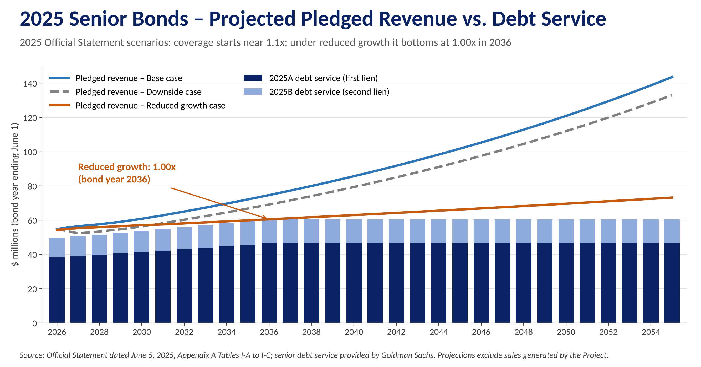
Figure C-1: 2025 senior bonds – projected pledged revenue versus debt service under the three Official Statement scenarios
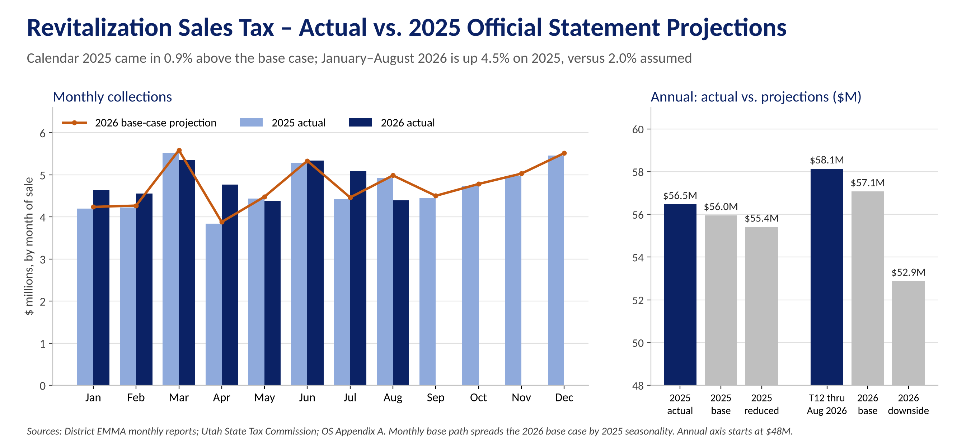
Figure C-2: Revitalization Sales Tax – actual collections vs. 2025 Official Statement projections
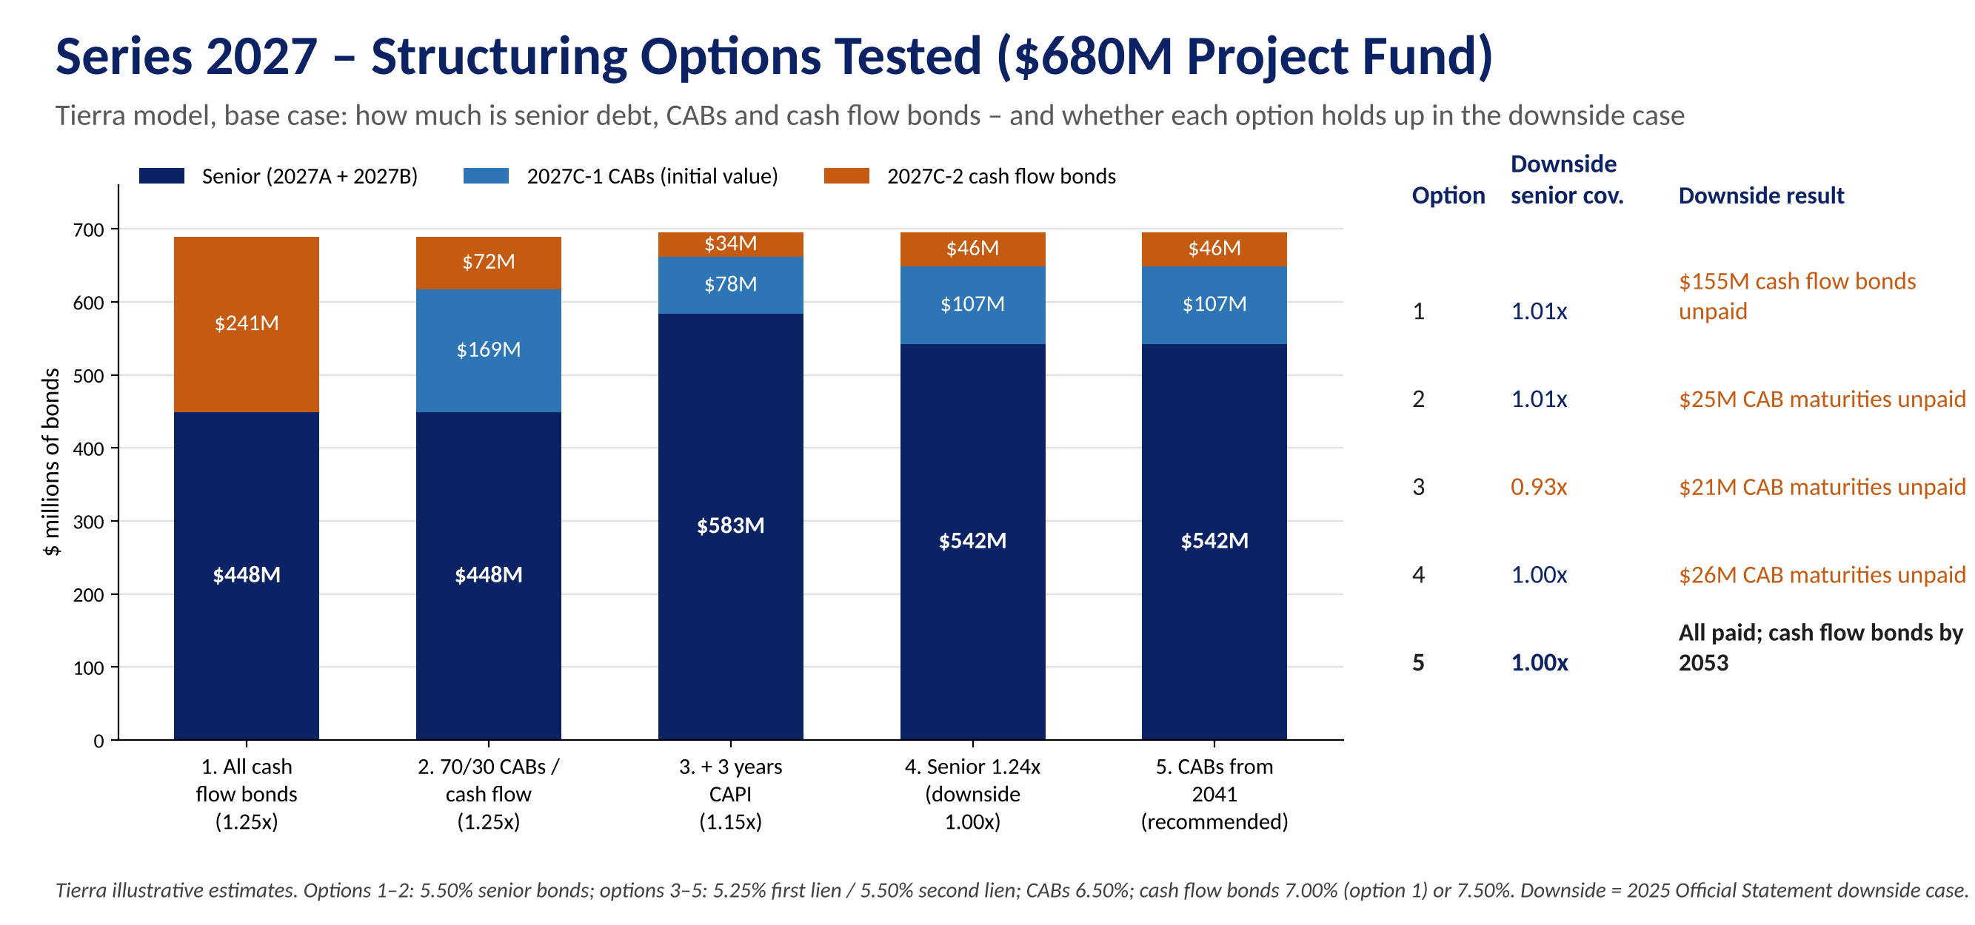
Figure C-3: Series 2027 – structuring options tested for a $680 million project fund (Tierra model)
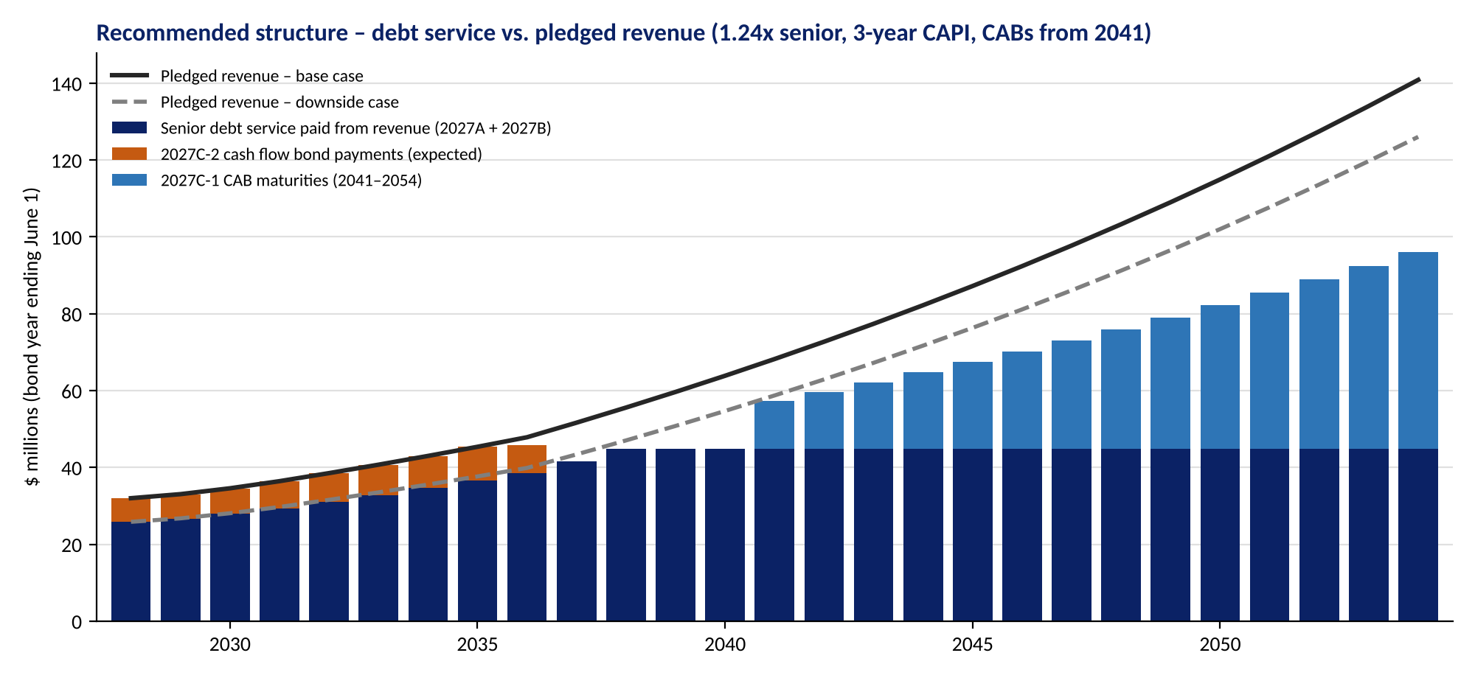
Figure C-4: Recommended structure – debt service versus base and downside pledged revenue (Tierra model)
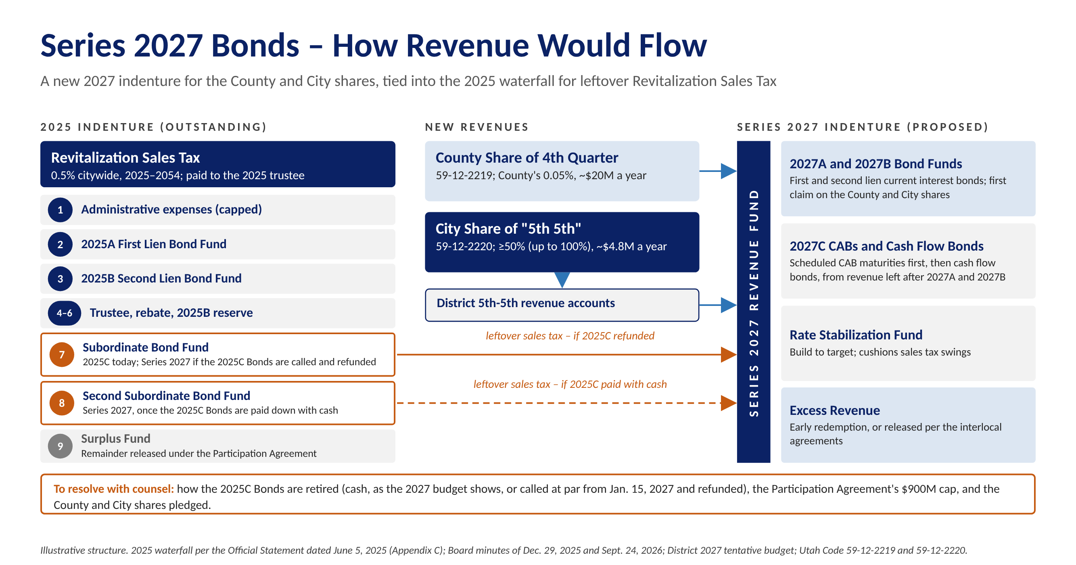
Figure C-5: Series 2027 Bonds – how revenue would flow (illustrative)
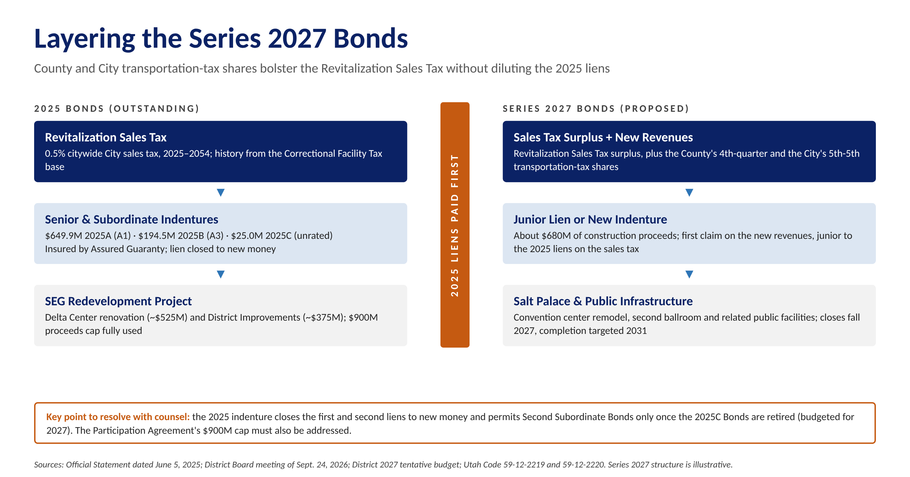
Figure C-6: Layering the Series 2027 Bonds beside the 2025 liens
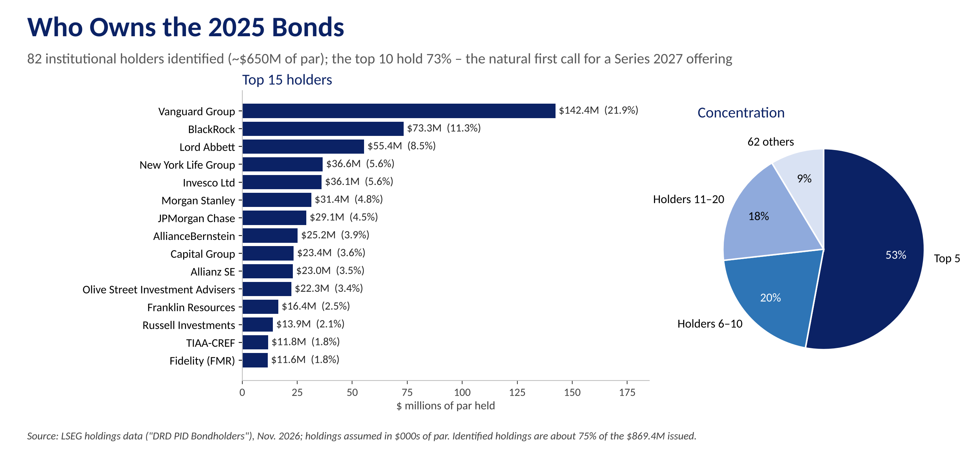
Figure C-7: Institutional holders of the 2025 Bonds

Appendix D – Series 2027 Preliminary Cash Flows
Below and on the following page is a snapshot of Tierra's proprietary cash flow model for the District: a $680 million project fund financed with Series 2027A first lien, 2027B second lien current interest bonds and and subordinate 2027C bonds. The first page summarizes sources and uses, bond statistics, the series structure, how the structure holds up under each revenue case, and the sizing assumptions. The second page shows debt service, pledged revenue, coverage and CAB maturities and expected cash flow bond payments by bond year. We include it to show the District the kind of independent analysis it would receive from Tierra before the Board sets the size, structure or timing of the Series 2027 Bonds. The model is live: pledges, coverage, rates, timing and the target project fund can all be changed with the Board and the financing team.
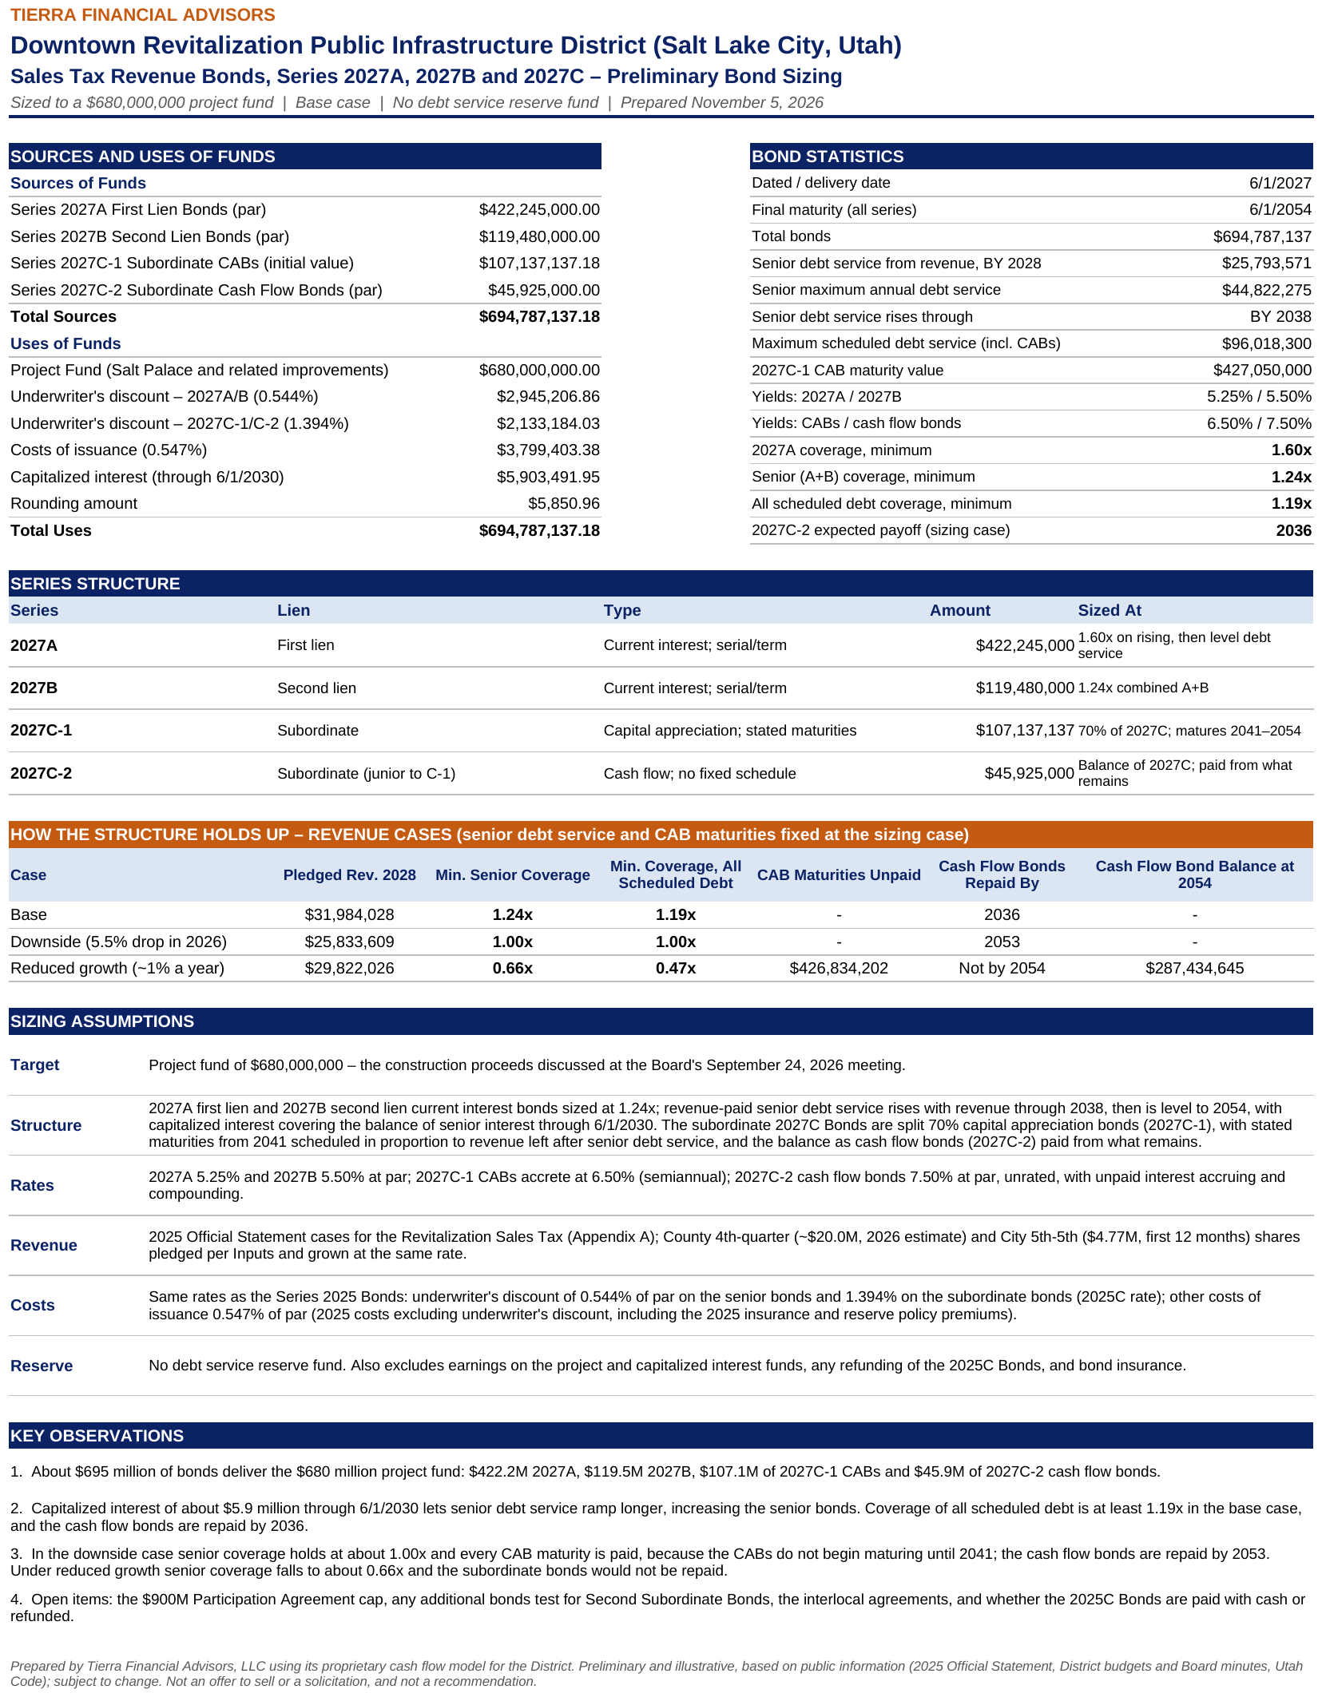
Figure D-1: Series 2027 preliminary bond sizing – summary (Tierra model, base case)
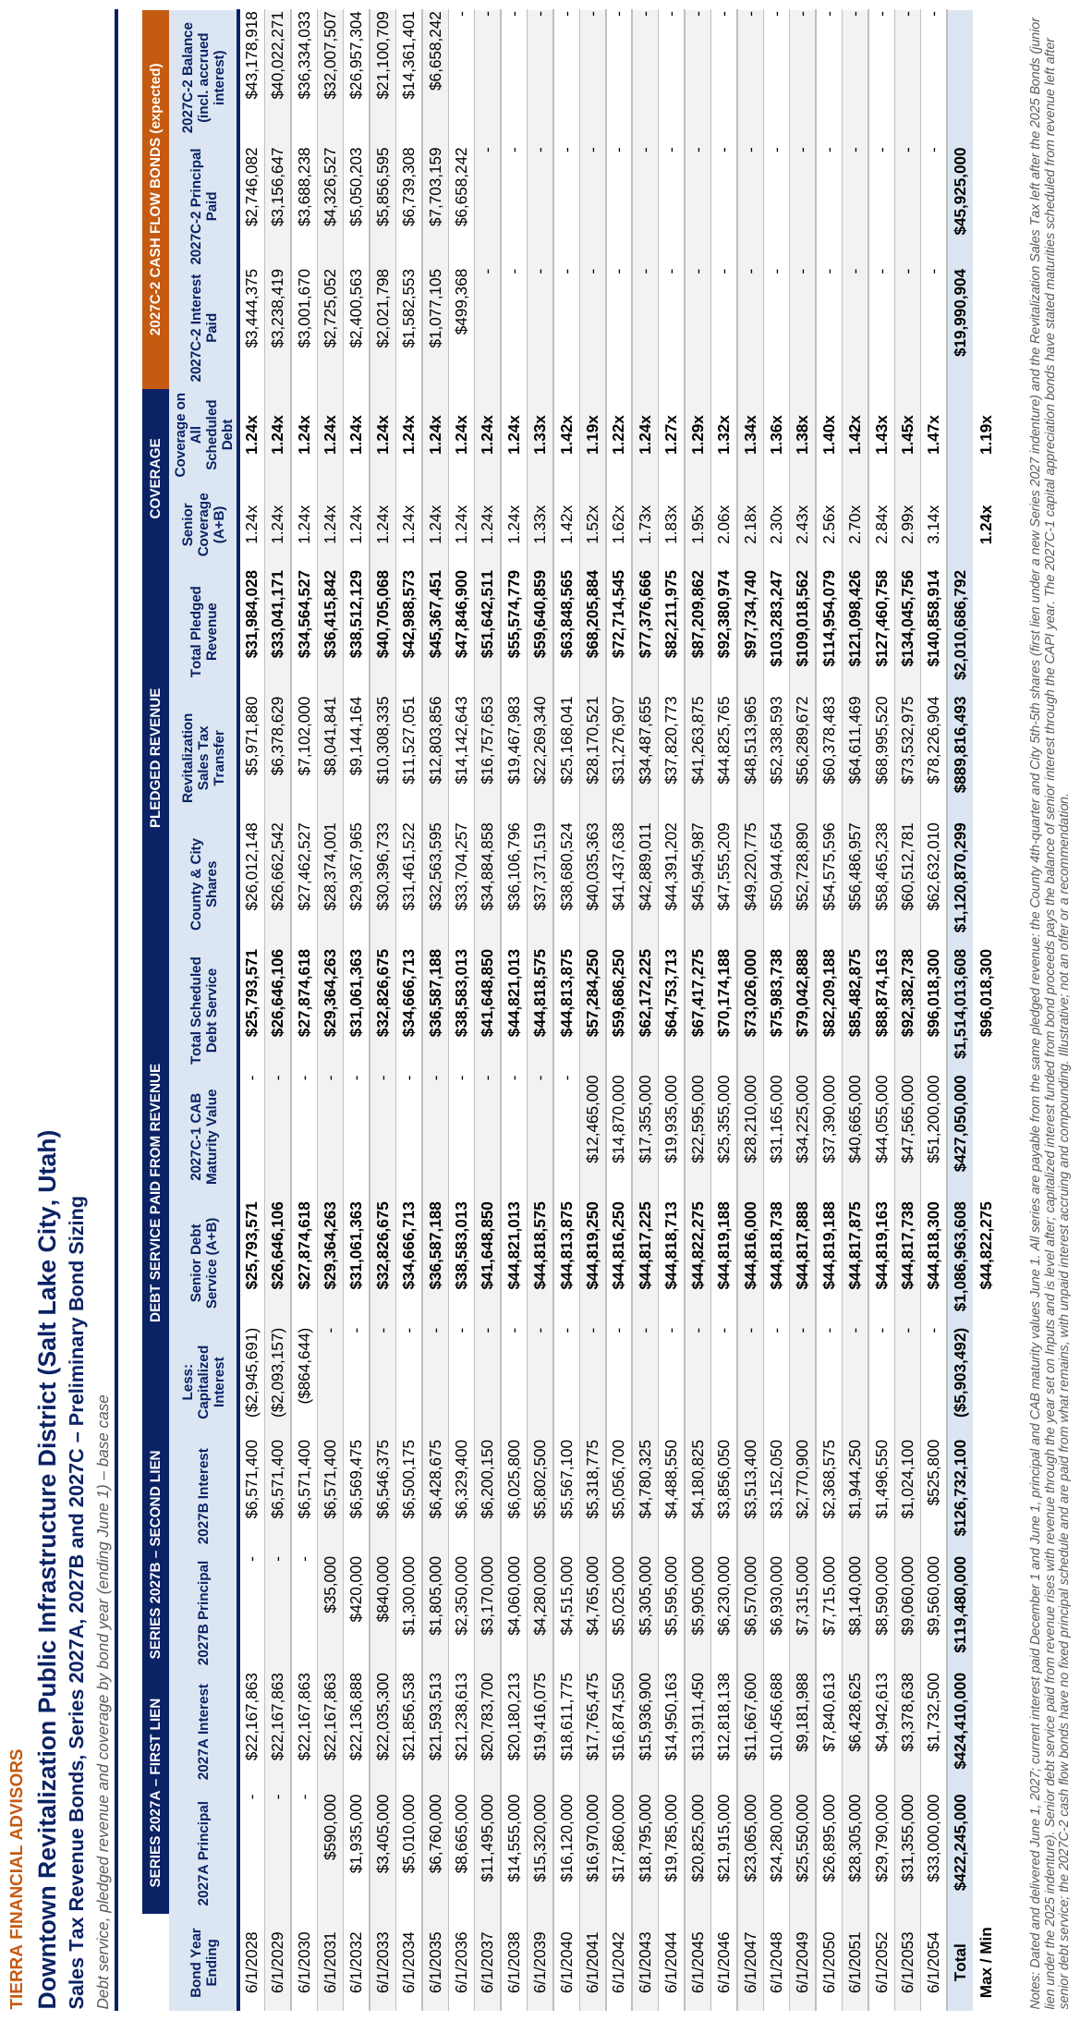
Figure D-2: Series 2027 debt service, pledged revenue and coverage by bond year (Tierra model, base case)

Structuring Options Tested
Before settling on the structure in Figures D-1 and D-2, Tierra tested five structures in the same model, each delivering a $680 million project fund. Each option builds on the one before it:
- Option 1 – senior bonds plus cash flow bonds. Mirrors the 2025 approach. Senior capacity is limited because first-year revenue must cover interest on the senior bonds, leaving about $241 million of subordinate cash flow bonds – a large amount of unrated paper – and $155 million of them unpaid in the downside case.
- Option 2 – split the subordinate bonds. Issuing 70% of the subordinate bonds as CABs with stated maturities cuts the cash flow bonds to about $72 million, but CAB maturities scheduled from 2028 go partly unpaid in the downside case, when little revenue is left after senior debt service.
- Option 3 – capitalized interest. Three years of capitalized interest (through June 1, 2030) lets senior debt service rise with revenue through 2038, increasing the senior bonds to about $583 million at 1.15x – but senior coverage falls to 0.93x in the downside case.
- Option 4 – protect the senior bonds. Sizing the senior bonds at 1.24x holds senior coverage at 1.00x in the downside case; CAB maturities in the early years still fall short.
- Option 5 – recommended. Starting the CAB maturities in 2041, after senior debt service levels off, directs early surplus to the cash flow bonds and leaves every CAB maturity and cash flow bond paid in the downside case. The trade-off is longer-dated CABs, which may price above the 6.50% assumed.
- Under the reduced-growth case (about 1% a year), no structure supported by these revenues keeps the senior bonds above 1.00x – the same is true of the 2025 senior bonds, which fall to 1.00x in that case.
Measure | Option 1 | Option 2 | Option 3 | Option 4 | Option 5
Senior coverage target | 1.25x | 1.25x | 1.15x | 1.24x | 1.24x
Capitalized interest | – | – | $6M | $6M | $6M
CAB share / first CAB maturity | – | 70% / 2028 | 70% / 2028 | 70% / 2028 | 70% / 2041
2027A first lien | $350M | $350M | $422M | $422M | $422M
2027B second lien | $98M | $98M | $161M | $119M | $119M
2027C-1 CABs (initial value) | – | $169M | $78M | $107M | $107M
2027C-1 CAB maturity value | – | $555M | $274M | $359M | $427M
2027C-2 cash flow bonds | $241M | $72M | $34M | $46M | $46M
Total bonds | $690M | $690M | $695M | $695M | $695M
Base: min. senior coverage | 1.25x | 1.25x | 1.15x | 1.24x | 1.24x
Base: min. coverage, all scheduled debt | 1.25x | 1.11x | 1.10x | 1.13x | 1.19x
Base: cash flow bonds repaid by | 2050 | 2044 | 2041 | 2041 | 2036
Downside: min. senior coverage | 1.01x | 1.01x | 0.93x | 1.00x | 1.00x
Downside: CAB maturities unpaid | – | $25M | $21M | $26M | –
Downside: cash flow bonds repaid by | Not by 2054 | Not by 2054 | 2049 | 2051 | 2053
Downside: cash flow bonds unpaid at 2054 | $155M | $23M | – | – | –
Reduced growth: min. senior coverage | 0.80x | 0.80x | 0.61x | 0.66x | 0.66x
Tierra illustrative estimates. Options 1–2: 5.50% senior bonds; options 3–5: 5.25% first lien and 5.50% second lien bonds. CABs 6.50%; cash flow bonds 7.00% (option 1) or 7.50%. Costs at Series 2025 rates; no reserve fund. Downside and reduced-growth cases from the 2025 Official Statement.

Stress Test – How the Structure Holds Up Under Each Revenue Case
Senior debt service and CAB maturities are held at the base-case sizing while pledged revenue follows each case. Coverage is shown on all scheduled debt (senior bonds plus CAB maturities). Any CAB maturity that revenue cannot cover is shown as a shortfall; the cash flow bonds are paid from what remains, and their balance (including accrued, compounding interest) shows how quickly they are repaid. Figures in $ millions.
Bond Year | Base: Pledged Rev. | Base: Sched. Cov. | Base: CAB Short | Base: CFB Bal. | Down: Pledged Rev. | Down: Sched. Cov. | Down: CAB Short | Down: CFB Bal. | Reduced: Pledged Rev. | Reduced: Sched. Cov. | Reduced: CAB Short | Reduced: CFB Bal.
2028 | 31.98 | 1.24x | - | 43.18 | 25.83 | 1.00x | - | 49.58 | 29.82 | 1.16x | - | 45.34
2029 | 33.04 | 1.24x | - | 40.02 | 26.74 | 1.00x | - | 53.46 | 29.61 | 1.11x | - | 45.81
2030 | 34.56 | 1.24x | - | 36.33 | 28.07 | 1.01x | - | 57.52 | 29.39 | 1.05x | - | 47.87
2031 | 36.42 | 1.24x | - | 32.01 | 29.70 | 1.01x | - | 61.74 | 28.99 | 0.99x | - | 51.71
2032 | 38.51 | 1.24x | - | 26.96 | 31.56 | 1.02x | - | 66.09 | 28.74 | 0.93x | - | 55.85
2033 | 40.71 | 1.24x | - | 21.10 | 33.51 | 1.02x | - | 70.58 | 28.48 | 0.87x | - | 60.29
2034 | 42.99 | 1.24x | - | 14.36 | 35.54 | 1.03x | - | 75.20 | 28.20 | 0.81x | - | 65.07
2035 | 45.37 | 1.24x | - | 6.66 | 37.66 | 1.03x | - | 79.94 | 27.91 | 0.76x | - | 70.20
2036 | 47.85 | 1.24x | - | - | 39.86 | 1.03x | - | 84.82 | 27.60 | 0.72x | - | 75.72
2037 | 51.64 | 1.24x | - | - | 43.38 | 1.04x | - | 89.58 | 28.49 | 0.68x | - | 81.66
2038 | 55.57 | 1.24x | - | - | 47.02 | 1.05x | - | 94.19 | 29.39 | 0.66x | - | 88.03
2039 | 59.64 | 1.33x | - | - | 50.79 | 1.13x | - | 95.09 | 30.29 | 0.68x | - | 94.89
2040 | 63.85 | 1.42x | - | - | 54.69 | 1.22x | - | 91.86 | 31.21 | 0.70x | - | 102.26
2041 | 68.21 | 1.19x | - | - | 58.73 | 1.03x | - | 97.46 | 32.13 | 0.56x | 12.46 | 110.19
2042 | 72.71 | 1.22x | - | - | 62.90 | 1.05x | - | 101.57 | 33.07 | 0.55x | 14.87 | 118.71
2043 | 77.38 | 1.24x | - | - | 67.22 | 1.08x | - | 104.02 | 34.01 | 0.55x | 17.36 | 127.87
2044 | 82.21 | 1.27x | - | - | 71.70 | 1.11x | - | 104.61 | 34.96 | 0.54x | 19.93 | 137.71
2045 | 87.21 | 1.29x | - | - | 76.33 | 1.13x | - | 103.13 | 35.92 | 0.53x | 22.59 | 148.29
2046 | 92.38 | 1.32x | - | - | 81.12 | 1.16x | - | 99.36 | 36.89 | 0.53x | 25.36 | 159.67
2047 | 97.73 | 1.34x | - | - | 86.08 | 1.18x | - | 93.03 | 37.87 | 0.52x | 28.21 | 171.90
2048 | 103.28 | 1.36x | - | - | 91.22 | 1.20x | - | 83.89 | 38.87 | 0.51x | 31.16 | 185.05
2049 | 109.02 | 1.38x | - | - | 96.54 | 1.22x | - | 71.63 | 39.87 | 0.50x | 34.23 | 199.18
2050 | 114.95 | 1.40x | - | - | 102.03 | 1.24x | - | 55.95 | 40.88 | 0.50x | 37.39 | 214.38
2051 | 121.10 | 1.42x | - | - | 107.73 | 1.26x | - | 37.15 | 41.90 | 0.49x | 40.66 | 230.71
2052 | 127.46 | 1.43x | - | - | 113.62 | 1.28x | - | 15.19 | 42.94 | 0.48x | 44.05 | 248.27
2053 | 134.05 | 1.45x | - | - | 119.72 | 1.30x | - | - | 43.98 | 0.48x | 47.56 | 267.14
2054 | 140.86 | 1.47x | - | - | 126.03 | 1.31x | - | - | 45.03 | 0.47x | 50.98 | 287.43
Source: Tierra Series 2027 Sizing Model. Base, downside and reduced-growth cases from the 2025 Official Statement, with the County and City shares grown at the same rate as the Revitalization Sales Tax in each case. Under reduced growth, senior coverage falls below 1.00x, CAB maturities go largely unpaid and the cash flow bonds are not repaid.

